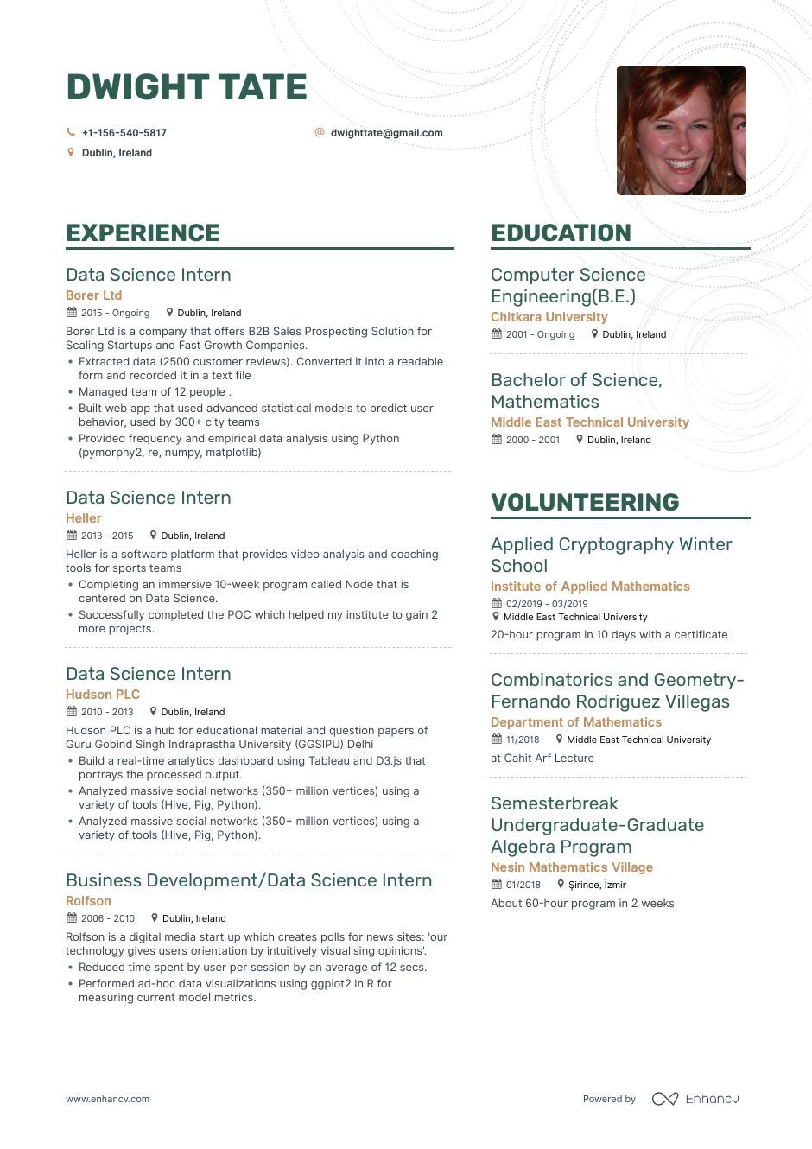
DWIGHT TATE
+1-156-540-5817
Dublin, Ireland
dwighttate@gmail.com
EXPERIENCE
Data Science Intern
Borer Ltd
2015- Ongoing Dublin, Ireland
Borer Ltd is a company that offers B2B Sales Prospecting Solution for Scaling Startups and Fast Growth Companies.
• Extracted data (2500 customer reviews). Converted it into a readable form and recorded it in a text file
• Managed team of 12 people.
• Built web app that used advanced statistical models to predict user behavior, used by 300+ city teams
• Provided frequency and empirical data analysis using Python (pymorphy2, re, numpy, matplotlib)
Data Science Intern
Heller
2013-2015 Dublin, Ireland
Heller is a software platform that provides video analysis and coaching tools for sports teams
⚫ Completing an immersive 10-week program called Node that is centered on Data Science.
Successfully completed the POC which helped my institute to gain 2 more projects.
Data Science Intern
Hudson PLC
2010-2013 Dublin, Ireland
Hudson PLC is a hub for educational material and question papers of Guru Gobind Singh Indraprastha University (GGSIPU) Delhi
• Build a real-time analytics dashboard using Tableau and D3.js that portrays the processed output.
• Analyzed massive social networks (350+ million vertices) using a variety of tools (Hive, Pig, Python).
• Analyzed massive social networks (350+ million vertices) using a variety of tools (Hive, Pig, Python).
Business Development/Data Science Intern
Rolfson
2006-2010 Dublin, Ireland
Rolfson is a digital media start up which creates polls for news sites: 'our technology gives users orientation by intuitively visualising opinions'. • Reduced time spent by user per session by an average of 12 secs. • Performed ad-hoc data visualizations using ggplot2 in R for measuring current model metrics.
EDUCATION
Computer Science Engineering (B.E.) Chitkara University
2001 - Ongoing Dublin, Ireland
Bachelor of Science, Mathematics
Middle East Technical University 2000-2001
Dublin, Ireland
VOLUNTEERING
Applied Cryptography Winter School
Institute of Applied Mathematics 02/2019-03/2019
Middle East Technical University
20-hour program in 10 days with a certificate
Combinatorics and Geometry- Fernando Rodriguez Villegas Department of Mathematics
11/2018
Middle East Technical University
at Cahit Arf Lecture
Semesterbreak
Undergraduate-Graduate Algebra Program
Nesin Mathematics Village 01/2018 Şirince, İzmir About 60-hour program in 2 weeks
www.enhancv.com
Powered by
Enhancu

